E();



# Reynoldsburg Lodge #340

**7350 Broadwyn Drive**

**Reynoldsburg, Ohio 43068**

**(614) 866-8179**

[**http://www.mason340.com**](http://www.mason340.com)

|  |  |
| --- | --- |
| **Stated Meetings:** | **1st and 3rd Tuesdays @ 7:30 PM** |
| **Special Meetings:** | **As called by WM** |

# Lodge Officers

|  |  |
| --- | --- |
| **Worshipful Master** | Alexander Jackson |
| [wm@mason340.com](mailto:wm@mason340.com) | 614-371-1424 |
|  | |
| **Senior Warden** | John Wronski, PM |
| [sw@mason340.com](mailto:sw@mason340.com) | 614-861-3883 |
|  | |
| **Junior Warden** | Monroe Bradley |
| [jw@mason340.com](mailto:jw@mason340.com) | 614-866-8439 |
|  | |
| **Secretary** | Gary Wehr, PM |
| secy@mason340.com | 614-202-1523 |
|  | |
| **Treasurer** | Buck Boyd |
| treas@mason340.com | 614-759-4398 |
|  | |
| **LEO** | Charles Ashley |
| [leo@mason340.com](mailto:leo@mason340.com) | 614-861-3425 |
|  | |
| **Trestleboard Editor** | Jack Freund |
| tb@mason340.com | 614-577-1062 |
|  | |
| **Web Editor** | Ken Cohen |
| Ken.Cohen@mason340.com | 614-577-0017 |

**Next Trestleboard Deadline**: 10 January 2015

***Mark Your Calendars!***

# Masonic Calendar

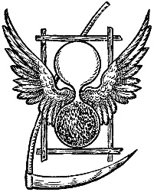

Growing old is no more than a bad habit which a busy man has no time to form. -Ande Maurois

|  |  |  |
| --- | --- | --- |
| **December** | | |
| 2 Dec | 340 Stated Meeting | 7:30P  6:30P – Dinner |
| 11 Dec | Linden Lodge Inspection | EA Degree |
| 13 Dec | PM Convocation @  South Gate-Potter Lodge | 8:00am – 12:00 |
| 16 Dec | 340 Stated Meeting | 7:30P  6:30P – Dinner |
| 20 Dec | Breakfast with Santa | 8:00A - 11:00A |
|  | | |
| **January** | | |
| 6 Jan | 340 Stated Meeting  Leather Apron Night | 7:30P  6:30P – Dinner |
| 6 Jan | University Lodge Inspection | EA Degree |
| 9 Jan | Magnolia Lodge Inspection | EA Degree |
| 20 Jan | 340 Stated Meeting | 7:30P  6:30P – Dinner |
| 27 Jan | Officer’s Meeting (PM’s invited, All Welcome) | 7:00P |
| 29 Jan | Triangle Lodge Inspection | EA Degree |
|  | | |

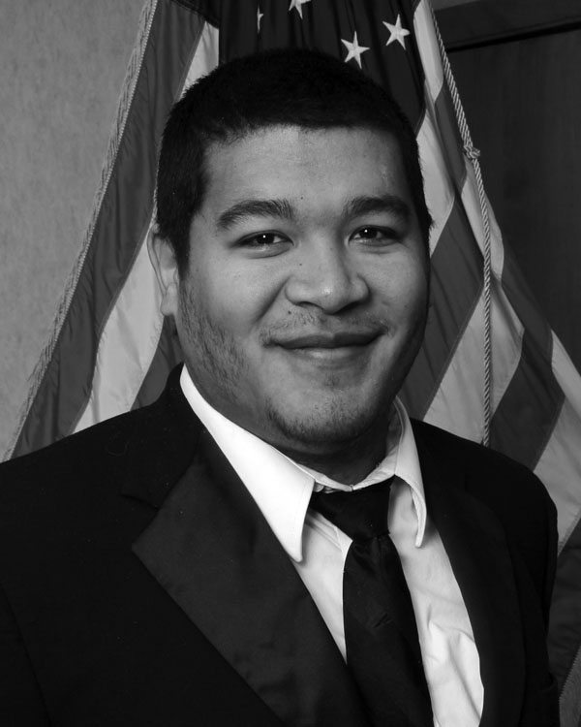

# From the East Alexander Jackson, WM

It is the start of a new year and new beginnings as the election season has now passed us. I am honored and humbled to have been elected to serve this upcoming Masonic year as Worshipful Master and I hope do right by those who have come before me and laid out a solid foundation for us to continue to build upon. The Lodge wouldn’t be where it is today without the support of each and every one of you and I thank you.

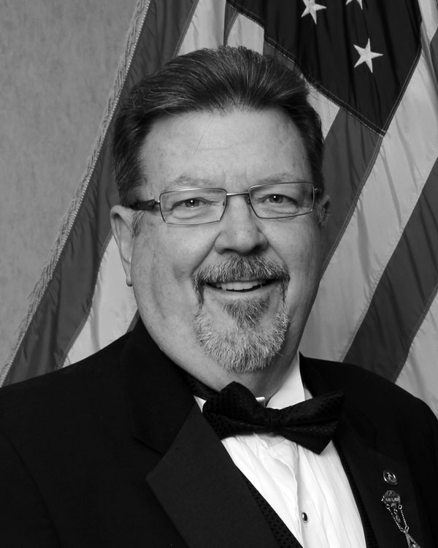To start our year, we have had a wonderful installation and awards night, and honored those who have been long serving Masons, those serving the community and even our newest of Brethren who has made it a priority to get involved and get the most out of Masonry. It was a joy to be able to see these faces in the Lodge and get to show them even a small amount of gratitude for being beacons to many.

The month of December will have our Lodge bustling with activity as has become the tradition. In addition to our two stated meetings on the 2nd and the 16th, Worshipful Brother “Claus” will be stopping by on 20 December for our Annual Breakfast with Santa. This will be our only breakfast for the month and it will be a wonderful present to see your faces, whether just visiting or helping make breakfast. Here’s to peeking at Santa’s List and seeing each of us marked as “Nice.”

The first stated in January will see us continue on with a recent addition to our Lodge traditions by having our “Leather Apron Night.” Unfurl that priceless apron that travelled through the degrees with you and means so much and to remember a little of the joy you felt as it was laid in your hands. This is a great chance to locate it and explain to a loved one the reason you protect it. It’s also a good time to make sure they know its location. Also coming up is “WILD GAME NIGHT” which will be the first stated in February. My appetite wishes every hunter a great season so that we all might enjoy the spoils.

I would also like to take this opportunity to invite the Past Masters of Reynoldsburg Lodge to come join us at the January 27 Officer’s Meeting at 7:00 P.M. As always this meeting is open to any Brother of the Lodge but I want to give the Officers a chance to hear from you and potentially walk away with an even better understanding of one another.

There is so much to do and I hope to see us accomplish everything we set out to do. I want to thank WB Martin for a great year and lots of memories and I hope to make many more for all those involved.



From the Secretary  
Gary Wehr, PM

One of the things a member dreads hearing is a Past Master that starts his sentence with “When I was Master…” Well, with the list of PMs getting longer behind my name I still see one common problem each Worshipful Master has had to deal with…getting members back in Lodge. True, some of our meetings have been pretty boring, lacking any motivation for you to come to Lodge. We open Lodge using the same ritual that has been used for hundreds of years; we pay our bills, discuss old business if any, discuss new business if any, do ritual work if any, close the Lodge using the same ritual and then go home. Boooooring! That was the way it was in my year and to some degree I am sorry to say it’s the same today. But…over the past few years things have started to change.

Our Lodge’s leadership has gotten younger. With youth come new ideas, new concepts, new energy, and a new outlook on the situation. As I look at the Lodge officers, I see young, enthusiastic men who want to make a difference in our Lodge; men who respect the past, who are committed to our heritage but also want to bring the Lodge into the 21st century and make it a place you want to be part of. Our education program is better than ever. We have a program almost every meeting. Bro. Charles Ashley has done a great job with these programs and gets the membership involved. It’s no longer someone just standing at the podium reading from a script that he obliviously didn’t write. His programs are enlightening, thought provoking at times and most of the time, a group effort. This alone is worth coming back to Lodge to see what you’re missing. But there’s more than just that.

These young men leading your Lodge also need your help. They need you to tell them what’s working and what isn’t. Without your input we can’t change. Without change our destiny is to remain boring. Help stamp out boredom! A great place to start is by coming to our monthly breakfast on the last Saturday of each month…except for this December when the breakfast will be on Dec 20th. This is our special breakfast, Breakfast with Santa! Bro. Scott Edgel has done a fantastic job with these monthly breakfasts. It rivals Bob Evans, Denny’s, and Cracker Barrel combined! The two biggest differences are, we cheaper and you dine with a room full of friends! Breakfasts are 8:00A-11:00A and are $6.00 for an all-you-can-eat meal. Let’s see Bob and Denny beat that!

Don’t want to come back because it’s been so long since you last attended? Afraid you don’t know due guards and signs? Never fear! Just let me or any officers know you’ve been away for a while and we’ll make sure you feel right at home. We will see that someone sits with you and answers any questions and walk you through the meeting. You’ll see…It’s like riding a bike!

# **K:\DCIM\100CANON\Buck - TB_edited-1.jpg**From the Treasurer Bro. Buck Boyd

Well, the Masonic year is complete and we are moving ahead into a new one. 2015 looks like it’s going to be a good one, with Breakfast with Santa on 20 December kicking off the lodge’s new year of events.

Since this breakfast is so close to the last Saturday of the month, we will not have breakfast on that date. Our next breakfast will be the last Saturday in January.

This year we did many things to get ourselves ready for the future. We purchased a trailer for our festival participation and established ourselves back into our community by participating in the Reynoldsburg Tomato Festival. We joined the Millersport Corn Festival and sold sloppy joes, pulled pork sandwiches, and hot dogs with great success. We hope to make both of these festivals our major fund raising events in upcoming years.

Despite all that we have invested in our future finances, we have lost OES as a tenant so it is important that we look for new ways to serve the lodge’s financial needs.

All Brothers at this lodge are important to the lodge’s future. Some, who have been a member for many years, have already put in a lot of hours working for the lodge. Others who are new to the lodge, but find they cannot attend regularly or give time to events are still valuable. 340 needs your ideas and support even if you can’t give time. This may be financial contributions or attending the monthly breakfast. I guess what I’m trying to say is you have a young and dynamic group of new officers that needs your help and support. Give them and the lodge what you can. It could be the difference between a successful lodge and a mediocre one.

With the books balanced and the audit completed, I wanted to take this opportunity to thank PM Gary Wehr, our lodge secretary, for all his help during this past year. I’d also like to congratulate WB Derek Martin on his year as Master and thank all of the Brothers who make my job as treasurer a great pleasure.

Our lodge is growing again and fellowship is prospering so come out and join us if you haven’t been for a while. Catch the fever of masonry again!



# Cornerstone Ceremony at Ricart Automotive

On 30 August 2014 at 10:00A, The Grand Lodge of Ohio laid a cornerstone on a new building at Ricart Automotive. This ancient ceremony has been conducted for centuries by Freemason are the world over to commemorate new construction in the community.

*Photo credit: Bro. James Winslow*

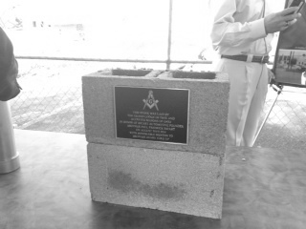

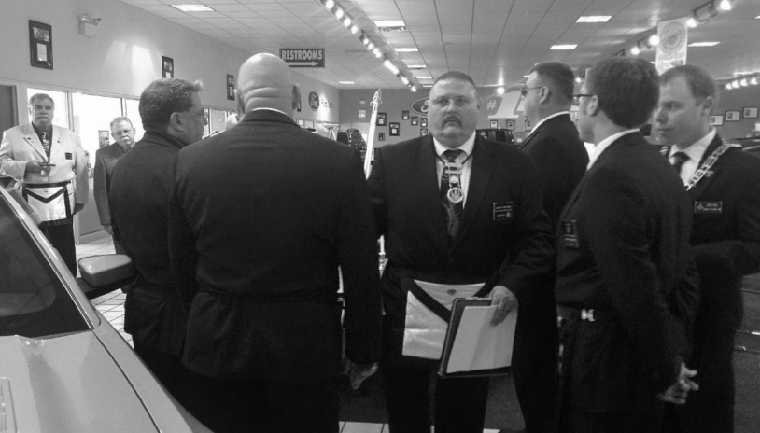

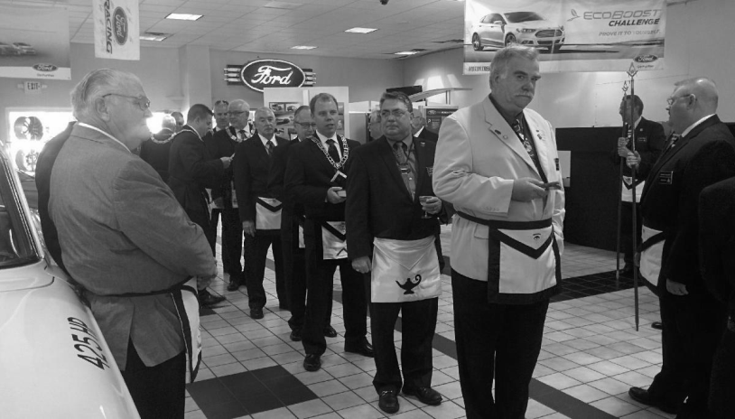

Rent the Lodge  
Got a big family gathering? Office party?  
Rent Godfrey Hall for your function  
Just $50 to rent Godfrey Hall   
for members of   
Reynoldsburg Lodge, Whitehall Lodge, or Eugenie Chapter  
Only $75 for non-members  
Additional Charge for kitchen use  
Contact WM Alex Jackson for details

From the Secretary and YOUR Lodge;

This serves as the second notice for those of you who have yet to pay your 2015 dues.

Please make out just one check. If you select “Lodge Misc. charities,” the Lodge will select the appropriate one depending on the greatest need after all the dues payments are received.

Please tear out this page and submit it with your payment.

|  |  |
| --- | --- |
| Lodge Dues | $65.00 |
| Lodge’s General Operation Fund | $ |
| Lodge Misc. Charities | $ |
| Grand Lodge Misc. Charities | $ |
| Ohio Masonic Home | $ |
| Specific Charity/Fund of Your Choosing | $ |
| **Total Amount enclosed** | **$** |

|  |  |
| --- | --- |
| Name |  |

**YOUR ANNUAL DUES ARE TO BE SUBMITTED TO THE SECRETARY BY 4 NOV 2014**

Please make your check payable to *Reynoldsburg Lodge #340*, and mail it to:

Reynoldsburg Lodge #340

℅ Gary Wehr

7933 Brookfield Pl

Canal Winchester, OH 43110

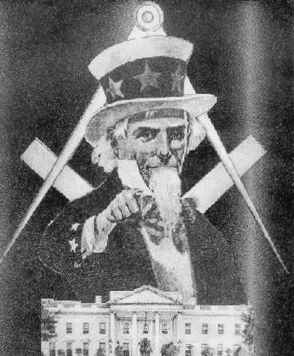

C:\Users\HPLaptop\AppData\Local\Microsoft\Windows\Temporary Internet Files\Content.IE5\CKZY9R3Y\MC900347069[1].wmf**C:\Users\HPLaptop\AppData\Local\Microsoft\Windows\Temporary Internet Files\Content.IE5\K3MPIL62\MC900038626[1].wmf**

**Don’t forget our monthly breakfast on the last  
Saturday of EVERY month, 8-11am. All you can eat for $6.** *With the exception of December***.**

**December’s Breakfast will be on Dec 20th. Same time – Same Place but with this difference…**

**One non-perishable food item will get you a photo with Santa!**

**2 items will get you two photos with Santa!**

**All food donations will be given to Reynoldsburg’s Helping Hands**

**C:\Users\HPLaptop\AppData\Local\Microsoft\Windows\Temporary Internet Files\Content.IE5\H8FZ69N2\MC900437565[1].wmf**

**Pictures from the 2015 Officer’s Installation**

**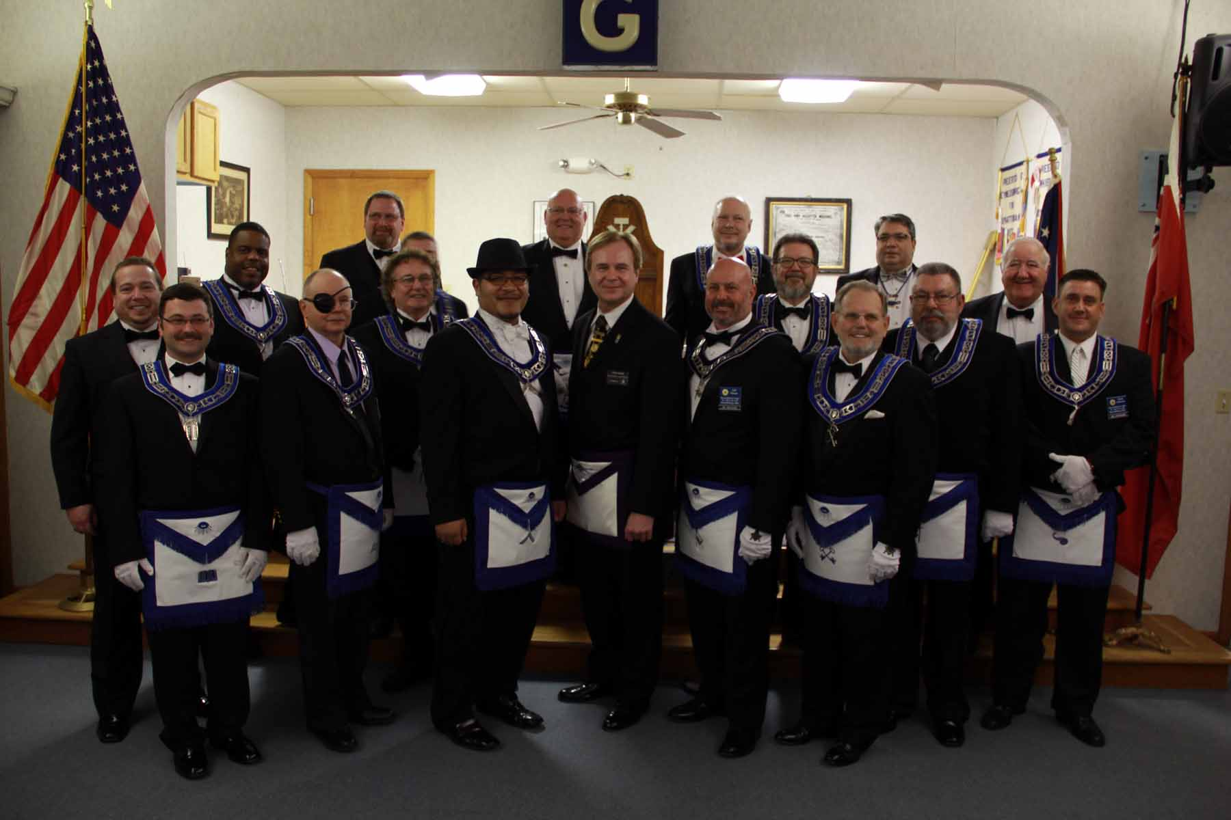**

**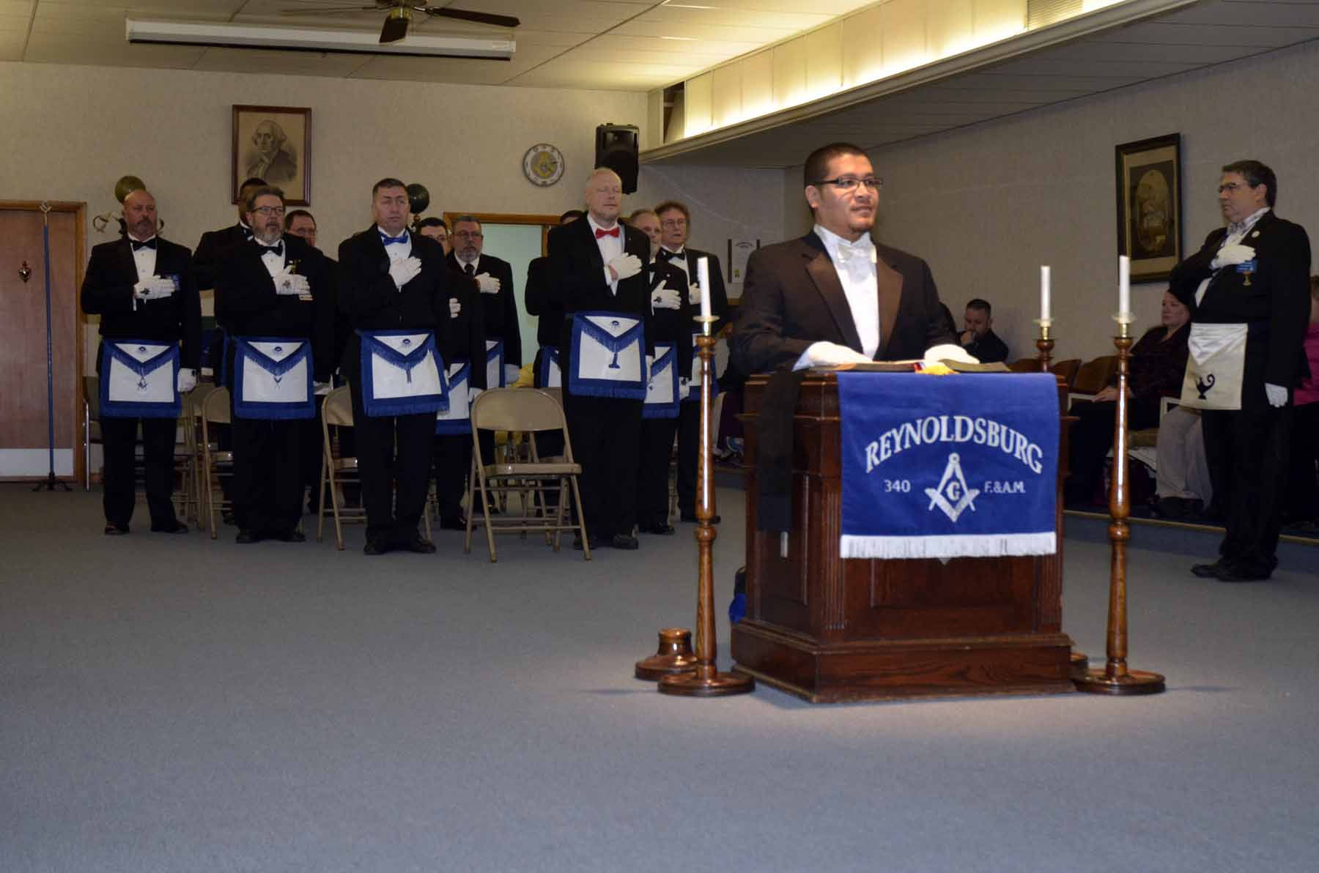**

**WM Alex Jackson and the Officers of Reynoldsburg Lodge**

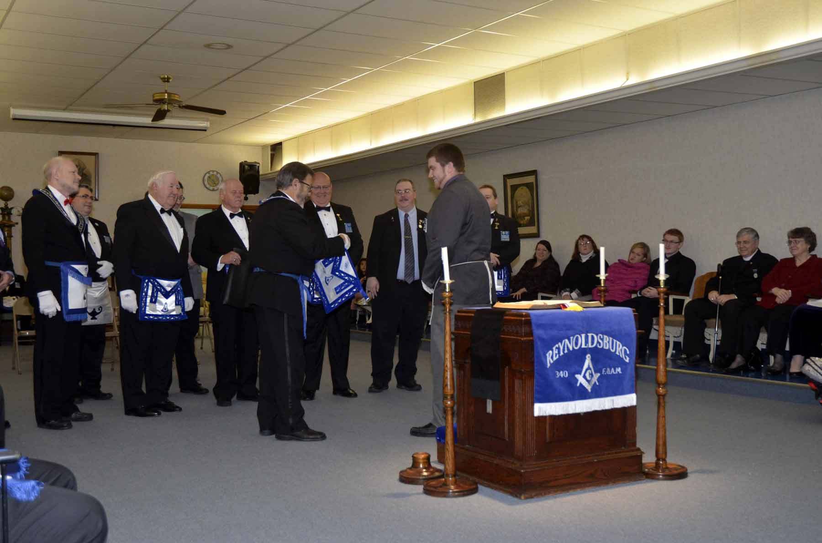

**WB Derek Martin receives his PM apron from WB Gary Wehr and the other PMs of the Lodge.**

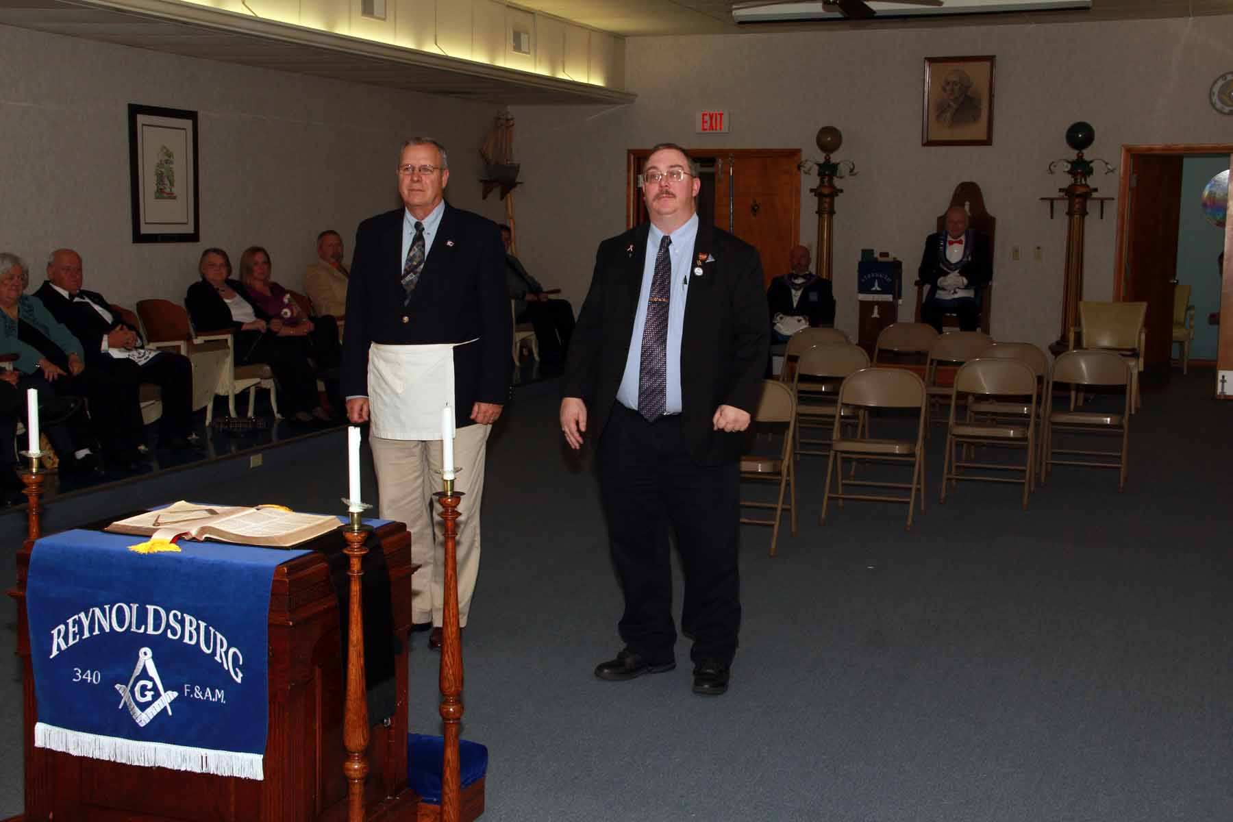

**Bro Jim Myers and WB Stephen Sharritts about to receive their 25 year pins**

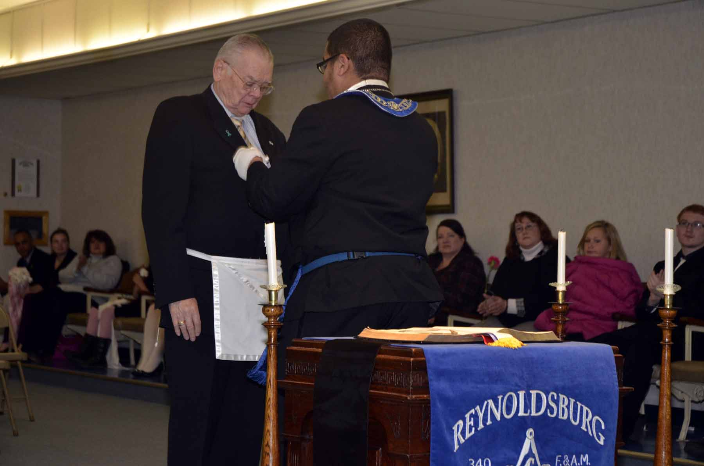

**Bro Dan Merrick receives his 35 year pin from WM Alex Jackson**

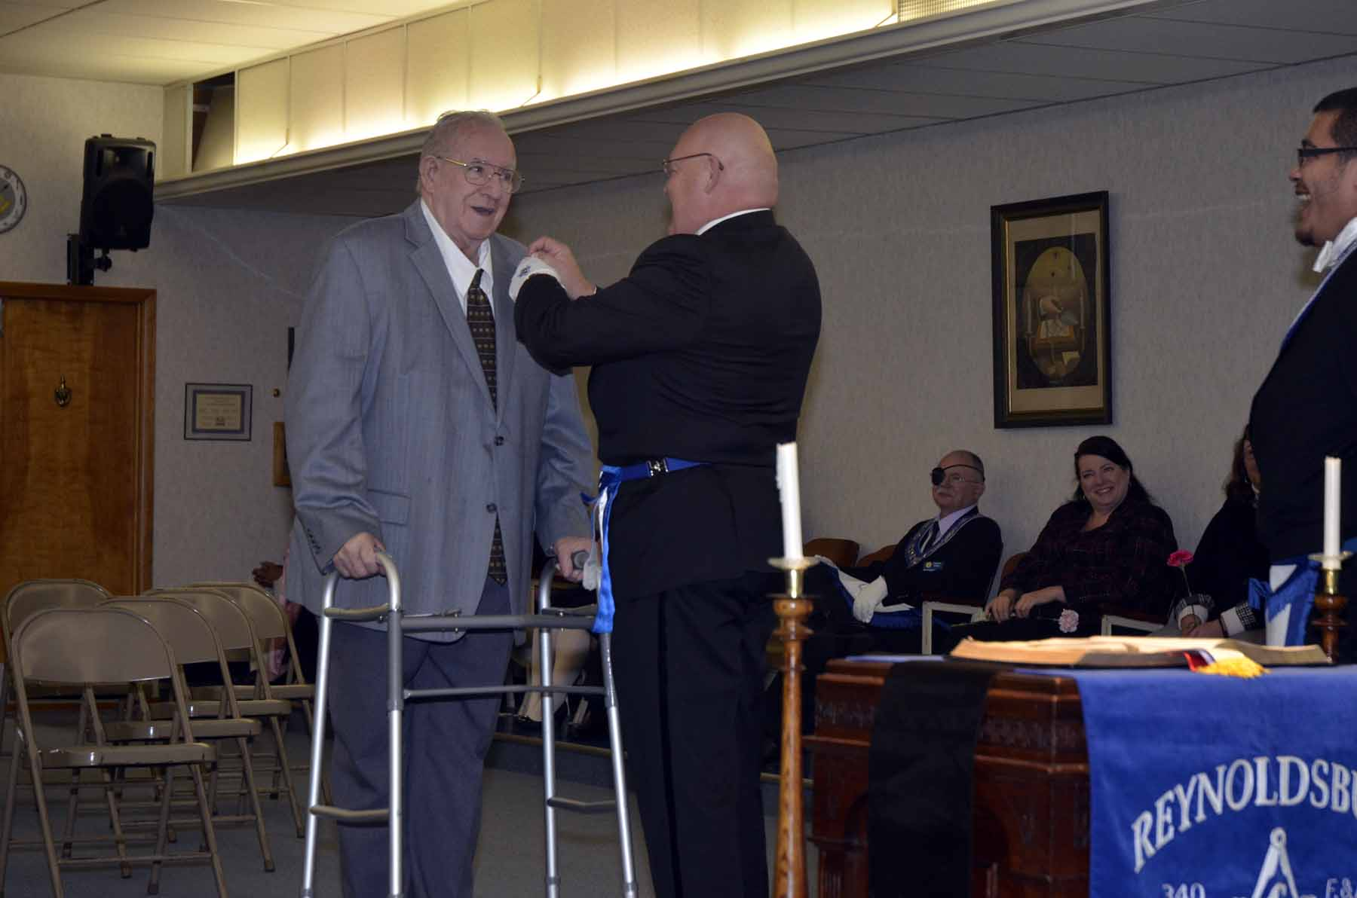

**Bro Dick Basye receives his 40 year pin from his son WB Rod Basye**

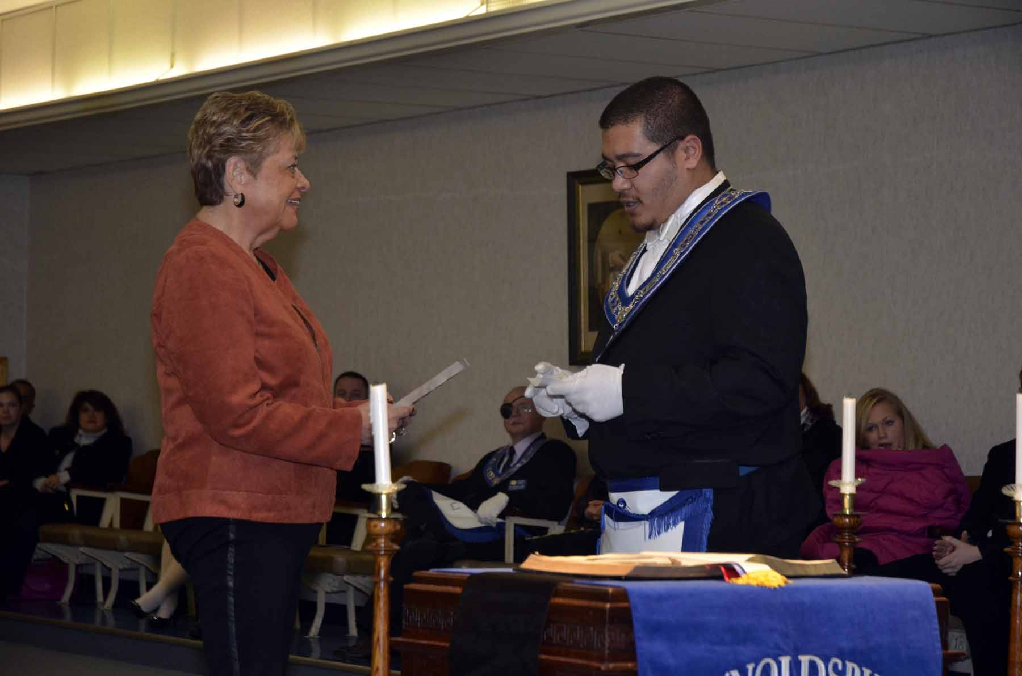

**Janet Munjas, Director of Reynoldsburg’s Helping Hands receives the Community Builder’s Award**

**and a check for $200 from WM Jackson**

Please support OUR SPONSORS

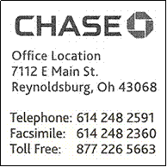

# Please support OUR SPONSORS





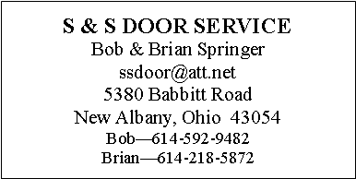



P.O. Box 624

Reynoldsburg Lodge #340 F&AM

Reynoldsburg, OH 43068

DATED MATERIAL – PLEASE DO NOT DELAY

NON-PROFIT ORGANIZATION  
U.S. POSTAGE PAID  
PERMIT NO. 30  
REYNOLDSBURG, OHIO 43068